Problem 1:

a)

i)

$$η_{degradation}={(1- ξ)}^{τ}={(1-0.0275)}^{10}=0.7767$$

ii)

$$η_{pointing}=\frac{P}{P_{θ=0°}}=cosθ=cos⁡(3°)=0.9986$$

iii)

$${\tilde{P}}_{sa}=η_{degradation} η_{pointing} {\tilde{P}}_{sa,1 AU} {\left(\frac{1AU}{R_{SC}}\right)}^{2}=0.7767* 0.9986*316 \frac{W}{m^{2}}*1=245.09 \frac{W}{m^{2}}$$

iv)

$$A_{sa}=\frac{P_{sa}}{{\tilde{P}}_{sa}}=\frac{1000 W}{245.09 \frac{W}{m^{2}}}=4.02 m^{2}$$

$$m_{sa}= A_{sa}ρ= 4.08 m^{2}*4.5 \frac{kg}{m^{2}}=18.36 kg$$

v)

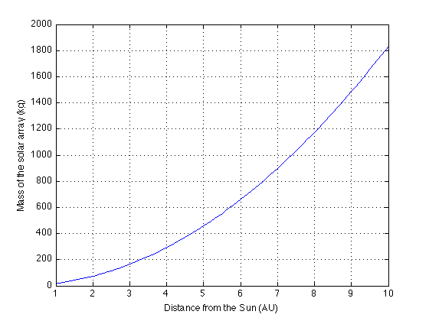

Figure 1: Distance from the sun versus the mass of the solar array.

b)

i)

$$P_{sa}= \frac{\sum_{k=1}^{n}{\left(\frac{P_{k}T_{k}}{X_{k}}\right)}}{\sum_{k=1}^{r}{T_{k}}}= \frac{\frac{250 W*\left(0.4\right)*90 m}{0.85}+ \frac{750 W*\left(0.6\right)*90 m}{0.85}}{\left(0.6\right)*90 m} =1078 W$$

ii) Assuming the same ${\tilde{P}}_{sa}$ as problem 1:

$$A_{sa}=\frac{P_{sa}}{{\tilde{P}}_{sa}}=\frac{1078 W}{245.09 \frac{W}{m^{2}}}=4.4 m^{2}$$

$$m_{sa}= A_{sa}ρ= 4.4 m^{2}*4.5 \frac{kg}{m^{2}}=19.80 kg$$

iii)

$$C_{bat}=\left(\frac{1}{\left(DOD\right)η_{conv}}\right) \sum_{k=1}^{q}{P_{k}T_{k}}= \left(\frac{1}{\left(0.65\right)*\left(0.9\right)}\right)*250 W*1.5 h*\left(0.4\right)=256.41 W∙h$$

iv)

$$m_{bat}= \frac{C_{bat}}{Γ_{bat}}= \frac{256.41 W∙h}{45 \frac{W∙h}{kg}}=5.69 kg$$

v)

$$m_{tot}=19.8 kg+5.69kg=25.49$$

c)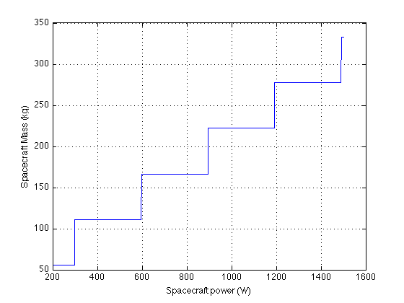

Figure 2: Spacecraft mass versus power.

d) It looks like it would be more desirable to use RTGs for outer planet missions, since the mass would be lower than the required solar array in most cases.

Problem 2:

a)

i)

$$F_{sc-Earth}=\frac{1}{2}\left[1-\sqrt{{1-\left(\frac{6378km}{6378km+350km}\right)}^{2}}\right]= 0.34$$

$$F_{sc-Space}=1- F_{sc-Earth}=1-0.34= 0.66$$

ii)

$$Q_{sun}=α_{sc}\left[πr_{sc}^{2}\right]S_{E}{\left(\frac{1 AU}{R_{sc}}\right)}^{2}= 0.75*π*{0.8}^{2}*1366.1*1=2060.0 W$$

iii)

$Q_{albedo}=α_{sc}\left[4πr_{sc}^{2}\right]F_{sc-Earth}α_{ }S_{E}{\left(\frac{1 AU}{R_{sc}}\right)}^{2}=0.75*4*π*{0.8}^{2}*0.34*0.3*1366.1*1=840.5$ W

iv)

$$T_{sc}={\left[F_{sc-Earth}{T_{E}}^{4}+\frac{Q_{sun}+Q_{albedo}+Q_{i}}{\left[4πr_{sc}^{2}\right]σε_{sc}}\right]}^{1/4}={\left[0.34*{290K}^{4}+\frac{2060W+840.5W+{125W}_{ }}{\left[4π{0.8m}^{2}\right]5.67*{10}^{-8}\frac{W}{m^{2}K^{4}} *0.9}\right]}^{1/4}= 314.44K$$

b)

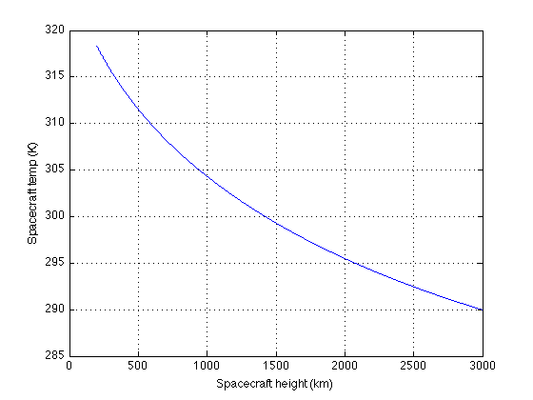

Figure 3: Spacecraft height from earth versus Spacecraft temperature

The results are what I expected since the earth gives off a great deal of heat that can be absorbed by the spacecraft, at least what the equations tell me. The same graph shape would appear as the spacecraft moved further from the sun. Problem 3:

a) Assume the pointing error is 20 degrees and that the thermal subsystem mass fraction is 3 percent

b)

|  |  |  |  |
| --- | --- | --- | --- |
| **Table 1: Power budget for NEAR spacecraft** |  |  |  |
| Element |  | Level 2 | Level 1 |
| 1.0 Payload |  |  | 93.5 W |
| 1.1 Multi-spectral Imager (MSI) |  | 13.9 W |  |
| 1.2 NEAR Imaging Spectrograph (NIS) |  | 20.0 W |  |
| 1.3 X-Ray/Gamma-Ray Spectrograph (XGRS) |  | 31.3 W |  |
| 1.3 Magetometer |  | 1.5 W |  |
| 1.3 Laser Rangefinder |  | 26.8 W |  |
| 2.0 Spacecraft Bus |  |  | 221.5 W |
| 3.0 Spacecraft Allocated Power |  |  | 315.0 W |
| 4.0 Margin |  |  | 93.5 W |
| 5.0 Total Power Available |  |  | 30.5 W |

c)

i) Cbat = 252 W-hr

ii) Cusable = 56.7 W-hr

iii) Battery Mass = 10.08

d)

i) End of Life Psa = 54.70 W/m2

ii) Area of solar array = 5.75 m2

iii) Mass of solar array = 29.94 kg

e)

PMAD mass = 1.37 kg

Wiring mass = 6.13 kg

f) Thermal subsystem mass = 9.19 kg

g) Structure subsystem mass = 72.91 kg

h) The induced errors in the above two values by using the historical dry mass fractions is mainly caused by using an arbitrary value (3-10 percent) for the Thermal subsystem mass. The other issue with using this for the structure subsystem mass is that we already know what mass fraction was used because this spacecraft has already launched. This value would not be known ahead of time, and even if we knew approximately what was needed based on a trend line, these values could change because of current technology.

i)

**Table 2: Mass break down for the NEAR spacecraft**

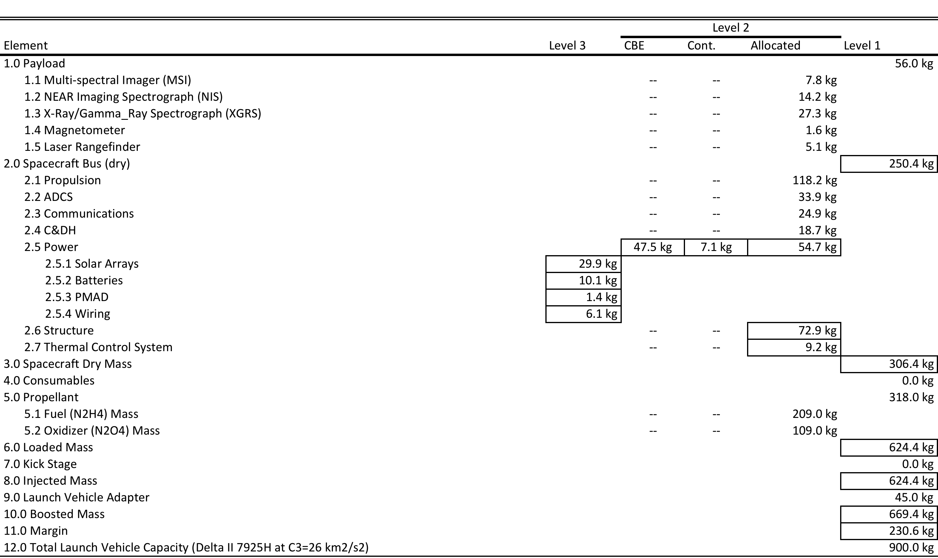

j)

Difference:

|  |
| --- |
| Solar Array Area – 3.14 m2 |
| Solar Array Mass – 16.16 kg |
| Battery Mass – 2.12 kg |
| Thermal Subsystem Mass – 1.81 kg |
| Structure Subsystem Mass – 29.29 kg |

Percent error:

|  |
| --- |
| Solar Array Area – 35.3% |
| Solar Array Mass – 35.05 % |
| Battery Mass – 17.38 % |
| Thermal Subsystem Mass – 16.45 % |
| Structure Subsystem Mass – 28.66 % |

There are several sources of error in the estimates, like the spacecraft allocated error, which is probably not the same value on the NEAR spacecraft. The historical mass fractions are just rough estimates based on empirical data. The pointing error or other errors were probably inflated a little bit (or just built in contingency) so the solar array area and mass were larger.